Configure “Router 2”
- Reset the router to factory defaults.
- Open your browser and type 192.168.1.1.
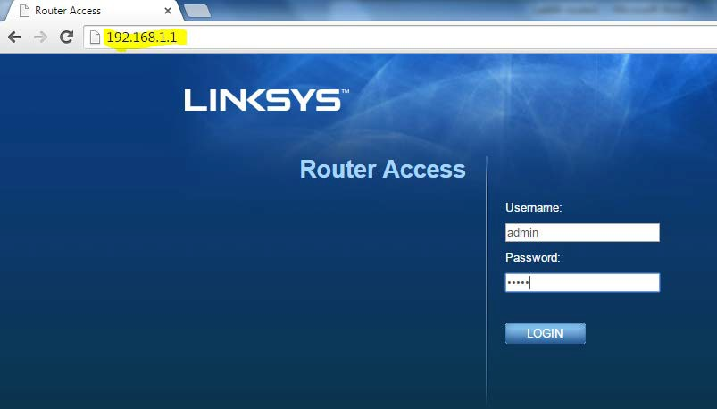
- Login to the router: username:admin. Password: admin

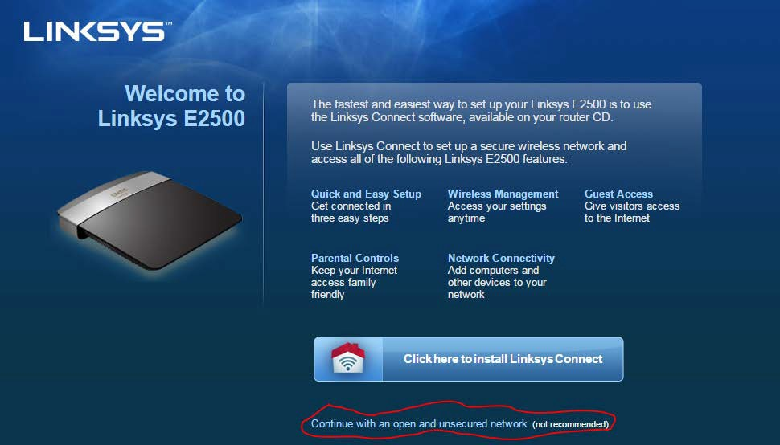
Wait for the router to reboot, and then reconnect to the routers. new IP address @172.16.254.254. Be patient, it may take a minute.

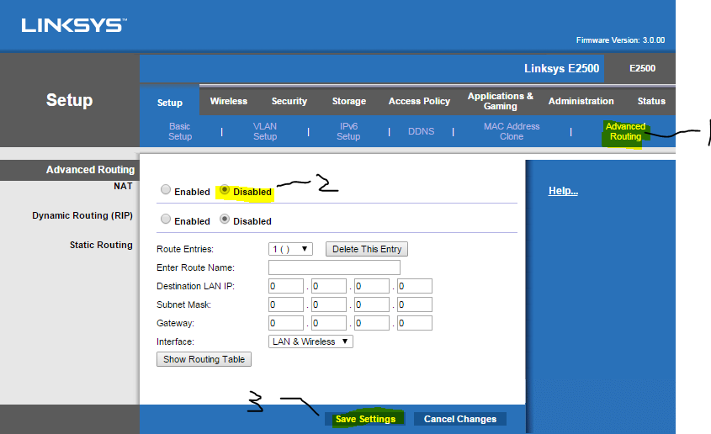
Disable NAT

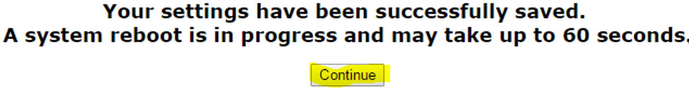

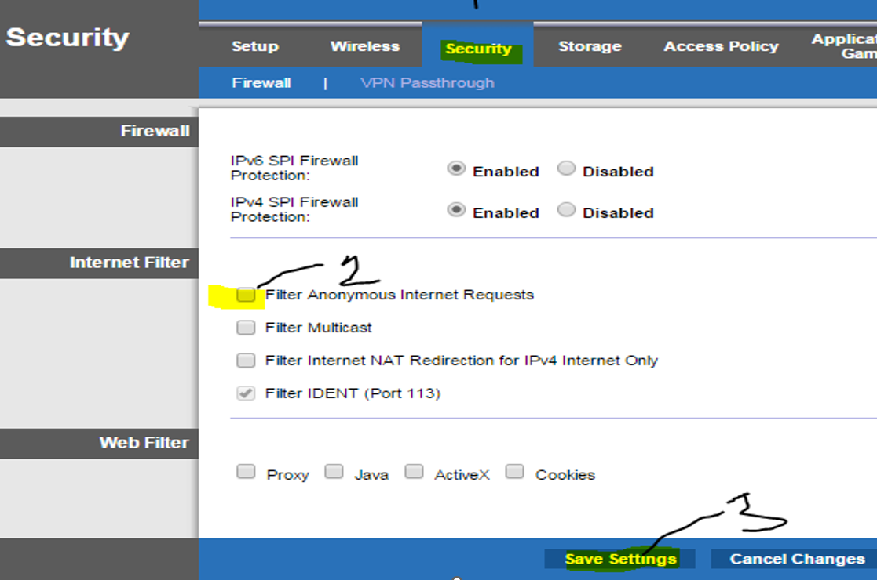

Uncheck Allow anonymous Internet Request

Routing Table Entry (static routing)
From your router’s (router 2) “Advanced Routing” configuration page (shown below), add a routing entry that will allow you to communicate with devices on “Network segment 1”.
REMEMBER THIS IS THE ROUTING ENTRY THAT WILL ENABLE YOU TO SEND PACKETS TO YOUR PARTNER’S NETWORK!
Create a static route with the following values:
- In field 1 enter an appropriate value. For example, LAN SEGMENT 1 or Rosie’s Network
- In field 2 enter the network id (destination) address of the network you wish to send packets to. Look at your topology diagram to determine the value to enter.
- In field 3 enter the subnet mask (Destination). Look at your topology diagram to determine the value to enter.
- In field 4 enter the next hop router IP address. Look at your topology diagram for the value to enter.
- In field 5 enter the outgoing interface for sending packets to this network. Select the appropriate interface. (WAN)
- Click the “Save Setting” and then click continue to return to the “Advanced Routing” configuration page.
- Click the “Show Routing Table” button to display your router’s routing table.
- Ensure that the new entry exists and contains the correct values!
- Take a screen capture of your router’s routing table, highlight the entry you just created and save as sc1-routingtable.
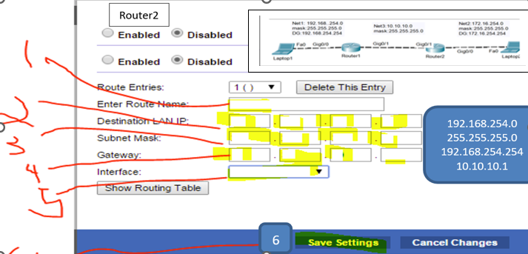

Network Connectivity Tests
- Local Connectivity Tests
  - ping 172.16.254.254 (your DG)
  - ping 10.10.10.2
- Wait for your partner to complete her/his router configuration before performing remote connectivity tests.

- Remote Connectivity Tests (your partner)
  - ping 10.10.10.1
  - ping 192.168.254.254 (partner DG)

- NOTE: You cannot proceed until both local and remote connectivity tests have succeeded.
- Record the following on your topology diagram:
  - your laptop’s IP and MAC addresses: 192.168.1.123 , 38-F3-AB-68-26-B3
  - your router’s (LAN) MAC address: C0:C1:C0:BC:67:2D
  - your partner’s laptop IP and MAC addresses:
  - your partner’s router (LAN) MAC address:

Return to the Task1 step 8 of the “Lab07 – InLab Activities” document.

